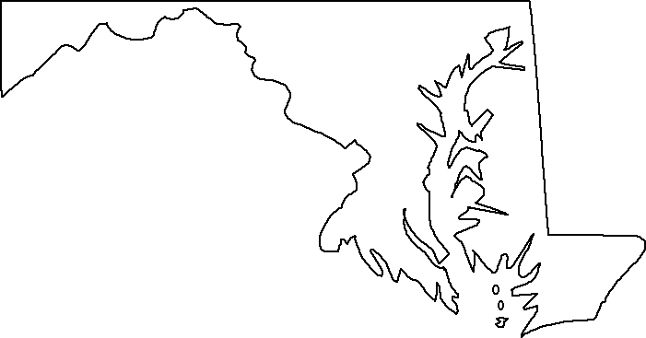
News From
U.S. Senator Barbara A. Mikulski
Democrat from Maryland

FOR IMMEDIATE RELEASE CONTACT: Melissa Schwartz
May 17, 2007 202-228-1122

MIKULSKI, CARDIN HONOR MARYLAND TEACHERS OF THE YEAR

WASHINGTON, D.C. – Senators Barbara A. Mikulski and Benjamin L. Cardin (both D-Md.) today met with Maryland Teacher of the Year Michelle Hammond of Stephen Decatur Middle School in Worcester County. The Senators also congratulated Teachers of the Year from each of Maryland’s counties. A high-quality photo from today’s event can be downloaded at: http://mikulski.senate.gov/teachers.html.
“As a social worker and legislator, my goal has always been to make sure everyone in America has access to a first-rate education, so that no child or community is left out or left behind. These teachers represent the best we have to offer,” said Senator Mikulski. “Congratulations to all the teachers across Maryland who make a difference in children’s lives every day. They are an inspiration to us all!”
“Studies show that good teachers are the key to helping students learn and succeed,” said Senator Cardin. “It’s important that we reward and recognize excellent teaching and that is why I want to congratulate the 24 teachers who have been selected as Maryland Teachers of the Year. Our state and our country owe you our thanks and our appreciation.”

The Maryland Teacher of the Year program recognizes and honors exemplary elementary, middle, and high school teachers that are excellent instructors and education leaders in their schools and communities. This includes a Maryland Teacher of the Year, and a local winner from each county. The Maryland State Department of Education (MSDE) oversees this program with all 24 local school systems participating.

Teachers in attendance today (in alphabetical order by county) were: Alan Hammond, Allegany High School (Allegany County), Susan A. Casler, Crofton Middle School (Anne Arundel County), Andrea L. Jackson, Northwood Elementary School (Baltimore City), Michelle L. Dressel, Loch Raven Academy (Baltimore County), Tamra Baurys, Greensboro Elementary School (Caroline County), Kenneth B. Fischer, Winters Mill High School (Carroll County), Sarah Smith, Milton M. Somers Middle School (Charles County), Lorraine Anders, Warwick Elementary School (Dorchester County), Mark C. Sunkel with Principal Margaret Lyburn, Linganore High School (Frederick County), Lisa M. Bender, Southern Garrett High School (Garrett County); Susan Jones Healy, North Bend Elementary (Harford County), Lisa M. Orem, Henry Highland Garnett Elementary School (Kent County), Denise Dunn, Deerfield Run Elementary School (Prince George's County), Honey Michele Voermann, Stevensville Middle School (Queen Anne's County), Andrew Todd, Somerset 6-7 Intermediate School (Somerset County), Nancy Souders, Smithsburg Middle School (Washington County) and Diana D. Churchman, Charles H. Chipman Elementary (Wicomico County).

Winners not in attendance were Barbara Redgate, Patuxent High School (Calvert County), Gail Dillaway, Rising Sun High School (Cecil County), Brooke Kuhl-McClelland, Hammond High School (Howard County), Robert Diserens Dahlin, Ridgeview Middle School (Montgomery County), Stephanie B. Flick, Benjamin Banneker Elementary School (St. Mary's County) and Lisa Kline, Tilghman Elementary School (Talbot County).
###

