
Maryland State Department of Education
Service-Learning Unit
Happy Helpers for the Homeless
Bobbi Coffman, bcoffman@aacps.org

Primary Subject: English Grade Level: 9th – 12th

Additional Subject Area Connections:

MSC Indicators Met

Content Title:
English:
- Indicator 3.1: The student will compose written, oral, and multimedia presentations in a variety of formats and for a variety of audiences and purposes.
- Indicator 3.2: The student will compose texts using the prewriting, drafting, revising, and editing strategies of effective writers and speakers.
- Indicator 5.1: The student will plan for, contribute to, and analyze successful oral communication.
- Indicator 5.2: The student will deliver effective oral presentations for a variety of purposes, in a variety of forms, and for a variety of audiences.
- Indicator 6.1: The student will process and analyze information presented orally.
Political Science:
- 1.A.3. The student will evaluate roles and policies the government has assumed regarding public issues (1.1.3).
Political Science

Unit Title: Happy Helpers for the Homeless

Type(s) of Service: Direct

Unit Description: Students study the issues surrounding homelessness and people in need. They contact local businesses, churches, and other schools to collect supplies and generate support for their cause. They assemble aid in the form of bag lunches, groceries, clothing, blankets, books, and toiletries and then distribute the supplies directly to men, women, and children in need. (If direct distribution is not possible, contact Happy Helpers for the Homeless, and they will arrange to pick up and distribute your materials.) Most importantly, though, the students take the time to communicate care to the people they are helping.

Potential Service-Learning Action Experiences:
- Advocate for the homeless and people in need by contacting community- based organizations.
- Create flyers, posters, or pamphlets to inform people about the issues surrounding homelessness.
- Collect supplies from community- based organizations for distribution to people in need.
- Direct distribution to the homeless and people in need.
- Collect supplies from community-based organizations to donate to Happy Helpers for the Homeless. They will pick up and distribute the materials to those in need.
- Host an in-school event in support of those served by Happy Helpers for the Homeless. (ie. a Freedom Harvest Food Drive or “Bag Lunch-Making Extravaganza”)
- Complete one of the six replicable Happy Helpers for the Homeless projects. (See attached, ie. “Bag-a-Breakfast”)
- Host an event for those served by Happy Helpers for the Homeless within the community. (ie. Birthday party for the homeless)
Alignment with Maryland’s
Best Practices of Service-Learning:
Happy Helpers for the Homeless

1. Meet a recognized community need
Every community has people in need. Happy Helpers for the Homeless finds those who are in the most need, and seeks to alleviate some of that need by distributing bag lunches, groceries, clothing, blankets, books, and toiletries. Most importantly, those served have a need for care from another person. The items are a direct reflection of care.

2. Achieve curricular objectives through service-learning
This project fits well with English and Political Science standards as students study the issue of homelessness and government policies on it. They then exercise their English skills by contacting local community based organizations to spread awareness and request assistance. Their communication skills are tested again as they work directly with and express care for the people whose needs they are addressing. Opportunities to expand the project can encompass more curricular objectives in other subject areas.

3. Reflect throughout the service-learning experience
Students will reflect throughout using discussions, question and answer sessions, and shared learning.

4. Develop student responsibility (Students have opportunities to make decisions about the service-learning project.)
Students have multiple opportunities to lead throughout the project as they serve as Team Captains on various major tasks. For example, students would be responsible for reporting their research findings, creating the action plan, and contacting the local businesses and organizations.

5. Establish community partnerships
Countless schools, businesses, churches, and groups work together on this project. Students work on contacting local grocery and retail stores, orchards, bread manufacturers, etc. and talking to the managers about the project. A major community partnership is formed with the population the students are serving.

6. Plan ahead for service-learning
Students are responsible for selecting a project and creating an action plan based on the findings of their research and the information presented by their guest speaker. The teacher will need to gather the resources for student research and arrange for the guest speaker. A distribution date and location will need to be determined.

7. Equip students with knowledge and skills needed for service
Students will be prepared for this project through the research they conduct and through the message of the guest speaker. This combined knowledge will prepare them for successfully serving the homeless and poverty-stricken.
Procedures with Resources:
Happy Helpers for the Homeless

These procedures represent an example of a service-learning lesson on this specific topic, but can be changed to meet individual classroom interests or varying community needs. You are encouraged to adapt this unit to fit your unique classroom and community and to solicit student input in planning and decision making.
Additional Interdisciplinary Connections

- Health:
- Students can study the necessary nutrition and plan meals for distribution.
- Students can study food preparation safety.
- Students can study mental health issues to be prepared for interacting with people in need.

- Have students study the issues surrounding homelessness and poverty. Have students research Happy Helpers for the Homeless. Using the Internet to search is recommended. Have students discuss their findings from their research.
- Contact the organization to arrange for a guest speaker to visit the class. The guest speaker will cover not only the history and mission of the organization, but all of the possible projects that students could take on. (See attached for six project ideas.) The guest speaker will describe the critical need for this type of service. Students will also gain knowledge on how to deal with the population they will be working with. Students will participate in a question and answer session.
- The class will discuss the potential projects and choose which project they will complete. They will need to compose and initiate an action plan.
- Students should contact community based businesses and organizations to gather the required supplies to complete their project. (ie. solicit local hotels for donations of blankets and toiletry articles.) This is an opportunity for students to advocate and share what they’ve learned.
- Make arrangements to pick up the donated items from the community businesses and organizations. As the students arrive to pick up the donations, they should present a student-written thank-you letter to the business or organization.
- Have students confirm the items are of a useable quality. Then, have them sort the items for distribution. As students sort through the donations, they should consider which items they would deem useable for themselves.
- Choose a date for the direct distribution of the materials. For a distribution location you can contact Happy Helpers for the Homeless or locate a site on your own. Arrange for transportation for the donations and the volunteers to and from the site. **If your school cannot directly distribute the materials, please contact Happy Helpers for the Homeless. They will pick up and distribute the materials on your behalf, and provide photos of the experience for your class.
- Bring students and volunteers to the distribution site. Organize and set up the donations upon arrival. Assign the students jobs. Typical jobs include assigning someone to distribute each item, someone to organize the line for the pick up of the items, and others to greet the people as they arrive. The most important job that each student is responsible for is a positive human interaction with those served.
- After the distribution is complete, have the students and volunteers reflect on the day. They should discuss what went well and what can be improved as well as what they experienced. Often reflection continues on the ride home.

Created: August, 2010

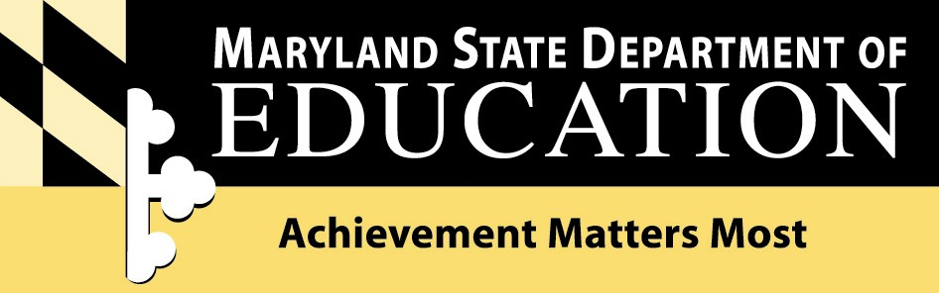

Division of Student, Family, and School Support
Youth Development Branch
200 West Baltimore Street
Baltimore, Maryland 21201
410-767-0358
www.mdservice-learning.org
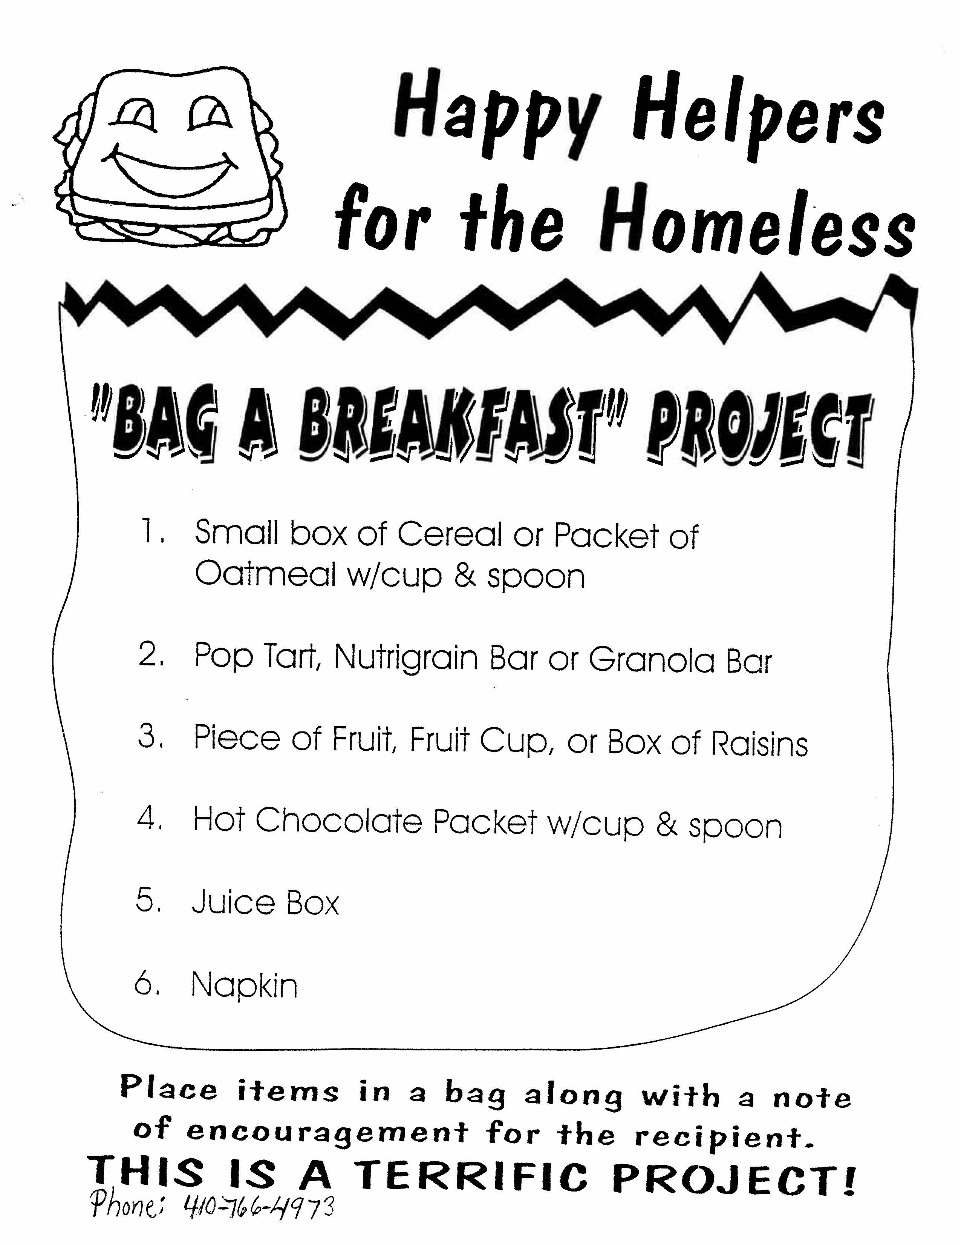
www.marylandpublicschools.org 